**CALCULATED FIELD FORMULAs Tableau**

**Conditional Formatting**

if [Cases] >= 300000 then "High Volume"

elseif [Cases] <300000 and [Cases] > 100000 then 'Mid Volume'

else 'Low Volume'

END

**LOD Aggregating Expression**

LOD (level of detail) calculations are enclosed inside curly braces

{KEYWORD [Dimension Declaration]: AGGREGATE([Expression])}

(FIXED, INCLUDE, EXCLUDE)

INCLUDE and EXCLUDE will always result in Measures

FIXED will default to Dimensions or Measures based on the Aggregate Expression

Sums up profit for each order id

{INCLUDE [Order ID]: SUM([profit]) }

{FIXED [Order ID]: SUM([profit]) }

{FIXED [Customer ID] : MIN(IIF([Order Date] > [1st Purchase], [Order Date], null)) }



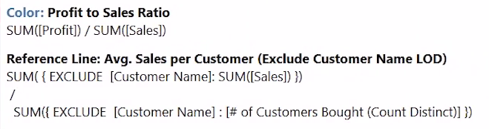

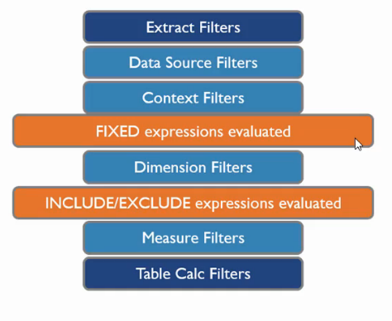

**Time Intelligence**

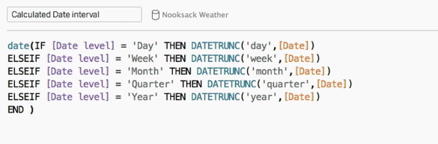

How many days to ship from Order Date

DATEDIFF(‘day’, [Order Date], [Ship Date])

**Aggregating**

AGG Aggregation

ATTR Attribute

SUM([Shipping Costs]) / ATTR( {SUM([Shipping Cost]) } )

**Average Order Sales**

SUM([Sales]) / COUNTD([Order ID])

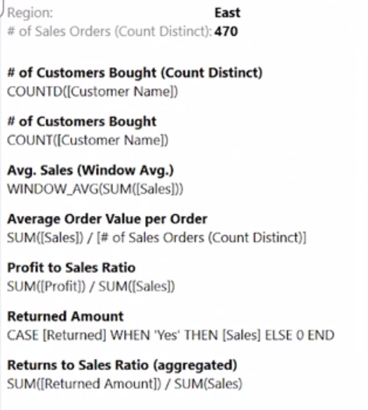

**NULL Function**

ZN = Zero Null

Converts a null to zero for aggregating

Use this when aggregating to accommodate for null

ZN([Quota]) says is there a quota? If not give it a zero